**DAILY ONLINE ACTIVITIES SUMMARY**

|  |  |  |  |  |  |  |  |
| --- | --- | --- | --- | --- | --- | --- | --- |
| **Date:** | 28/6/2020 | | | | **Name:** | Vleena Mascarenhas | |
| **Sem & Sec** | 8th & B | | | | **USN:** | 4AL16CS121 | |
| **Online Test Summary** | | | | | | | |
| **Subject** | | - | | | | | |
| **Max. Marks** | | - | | **Score** | | - | |
| **Certification Course Summary** | | | | | | | |
| **Course** | Developing Machine Learning Applications | | | | | | |
| **Certificate Provider** | | | AWS | **Duration** | | | 21/2 hours |
| **Coding Challenges** | | | | | | | |
| **Problem Statement:**  Python program to check if the given number is Happy Number | | | | | | | |
| **Status:** Solved | | | | | | | |
| **Uploaded the report in Github** | | | | yes | | | |
| **If yes Repository name** | | | | vleena | | | |
| **Uploaded the report in slack** | | | | yes | | | |

Certification Course Details: (Attach the snapshot and briefly write the report for the same)

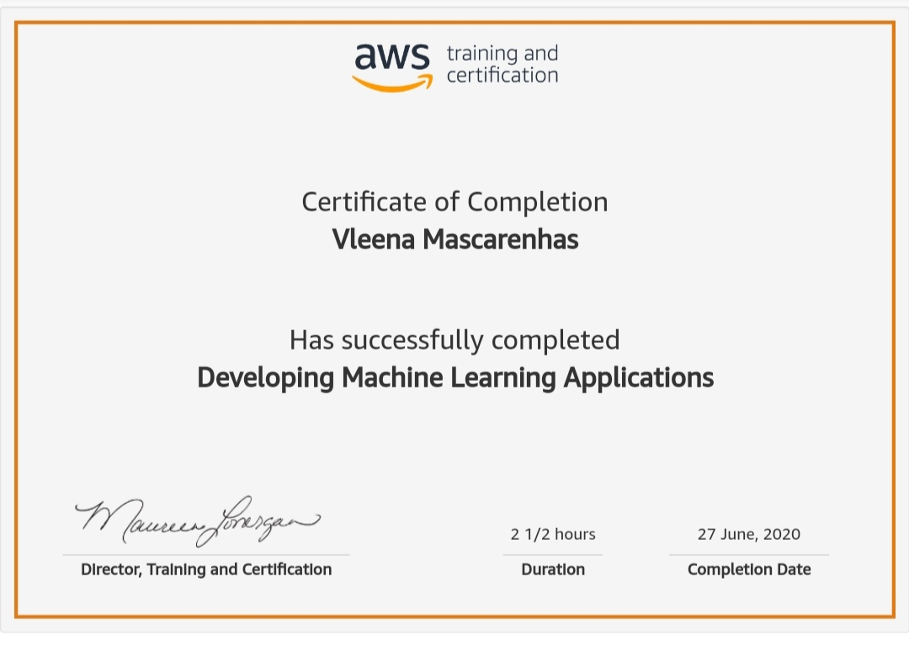

Coding Challenges Details: (Attach the snapshot and briefly write the report for the same)

**Problem Statement:**

Python program to check if the given number is Happy Number

def isHappyNumber(num):

rem = sum = 0

#Calculates the sum of squares of digits

while(num > 0):

rem = num%10

sum = sum + (rem*rem)

num = num//10

return sum

num = 82

result = num

while(result != 1 and result != 4):

result = isHappyNumber(result)

#Happy number always ends with 1

if(result == 1):

print(str(num) + " is a happy number")

#Unhappy number ends in a cycle of repeating numbers which contain 4

elif(result == 4):

print(str(num) + " is not a happy number")

**OUTPUT:**

82 is a happy number